|  |  |  |  |  |
| --- | --- | --- | --- | --- |
| Test Case | Input | Expected Output | Actual Output | Pass? |
| 1a | 1 | 3 random digits | 6 0 7 | Yes |
| 1b | 1 | 3 random digits | 0 1 3 | Yes |
| 1c | 2 | 4 random digits | 4 3 6 8 | Yes |
| 1d | 2 | 4 random digits | 6 3 7 4 | Yes |
| 1e | # | Error | Error | Should be handled by exceptions for the future |
| 1f | 95 | Since not 3 keep looping | Since not 3 keep looping | Yes |
| 1g | 3 | Exit program | Exit program | Yes |

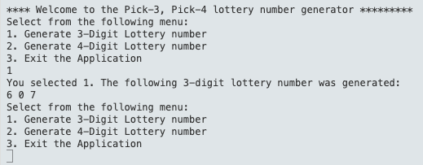

Figure 1. Test Case 1a Execution results

Figure 2. Test Case 1b Execution results

Figure 3. Test Case 1c Execution results

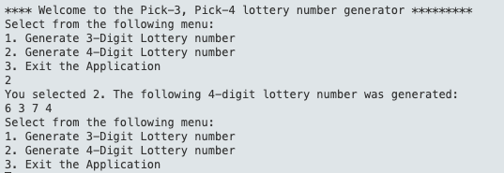

Figure 4. Test Case 1d Execution results

Figure 5. Test Case 1e Execution results

Figure 6. Test Case 1f Execution results

Figure 7. Test Case 1g Execution results